

**Sri Lanka Institute of Information Technology**

3rd Year 1st Semester (June Batch) - 2015

**Project Details**

|  |  |
| --- | --- |
| Project Title | Online Bus Booking System (Click & Go) |
| Project ID | PDM_15 _06 |

**Group Members**

|  |  |  |
| --- | --- | --- |
|  | **Name with Initials** | **Registration Number** |
| 1. | Sivalkar.T.S | IT13046880 |
| 2. | S.Kirshanth | IT13044664 |
| 3 | Piumal Dinuka w | IT13087234 |
| 4 | A.H.S. Sachithra | IT13110130 |

# Introduction

Sri Lanka is most important country in Travel Industry. Now a day’s more than 75% people use to travel by bus. However most of people who lived Sri Lanka they don’t know the details of bus stops, bus roots, bus Schedule etc… because of that they facing many inconvenient. So we decide to create Android application called **Online Bus Booking System.**

**Online Bus Booking System** is an integrated Android Application developed for Travelers in Srilanka. The main aim of this project is to help the people Book Bus Ticket through online. It makes all operations easy and accurate. The online platform makes travel **management** easy by handling passenger requests and providing services for the passengers located at different parts of our country.

This Android application is implemented to booking facilities easier which display list by a simple click and also make inquiries very quickly. This system will provide time consumption, easy access, and user friendly.

## Problem Specification

Finding Srilanka`s roots and bus stops are very complex for Passenger. Passenger can be get travelling information on Travailing agents and his own android application.

If passengers want to buy a ticket they need to go Bus Stations or Booking centre so their wasting time and Energy.

Passenger can reach their destination in different routes. There are so many transportation methods available in the same destination. So they are confused and some time they are facing some security threads.

## Product Scope

Online Bus Booking Application. With the implementation of this application. time can be saved and information obtained can be much reliable and secure. Main advantage of this application is to centralize all the functions of the system such as Booking bus & Seats , Administration function , Maintain cost and expenses System safety is maintained by using different features like Security Center, Help Center etc.

The main function of this system is Booking seats that travelers selected their feavourite place using their smart phone and atractive User interface in the application

This System also serves as -

* + A convenient way of combining the functions for efficient outputs.
  + Automated application update daily seat levels.
  + Carry out everyday functions with greater ease.
  + Give fast access to data.
  + Perfectly controls user and admin accounts.

## Project Report Structure

This Final Report provides a document describes how the issues were solved efficiently with the implementation of the application, this will explain about the final product and how its basic and special features helped the company to overcome its past issues. The expected audience of this document includes the supervisors, jury panel which will judge our project, users of the Click and Go application, administration and high authorities of RSL. Full in depth information of the system which was built in the time period of 3 months are listed in this document together with respective diagrams. This report also includes problems that developer team came across during the development of the system, solutions for them and future development of the system. This will give a clear idea for the reader about the project, The Structure of the final report is listed below.

|  |  |  |
| --- | --- | --- |
| Chapter No | Chapter Title | Purpose |
| 2 | Methodology | Detailed and specific requirements of the project. Various UML Diagrams to explain the design of the software product, Special Implementations and test cases are also listed here to show the reliability of the final product. |
| 3 | Evaluation | Techniques which were used to analyze the data and their results. Major Issues faced by the developing team. List if drawbacks of the final product if there are any. Lessons learnt by group individuals and the expected future works to the product are listed here. |
| 4 | Conclusion | Summary of the whole project. Original objectives/goals and Future goals of the developers. List of all the benefits of this project to the client organization |
| 5 | References | All the references and List of UML sub diagrams, Sample codes, use case scenarios and all the test cases. |

Table 1.3.1 Details of the rest of the report

# Methodology

## Requirements and Analysis

Bus maintenance:

Bus maintain details Cost Management ( Add maintenance cost each bus

Ex: Fuel, cleaning ,) View the maintain cost each bus)

Deliver the items to customer, delivery item details, and transport vehicle details. Assign and manage Driver details. Calculate vehicle maintenance cost. Manage vehicle availability status.

Abstract

Travel Industry provides vehicle-based services such as Transport service to Travelers those who need services.Then we research what are the problems occur in the service and how the travelers facing that problem then we made up a soliution for travelers called online Bus Booking System in Android.The Travelers currently utilizes a manual Booking system. for an example

Passenger want to book a seat in the bus they need to go Bust Ticket Booking center and book their ticket or manages to make deals with over the phone. The Travelers have been facing several disadvantages due to their way of handling the manual Booking system.

Such has waste of time and enargy . In order to reduce workload we build a Android application for online bus booking it makes their work esier .

The following document summarizes the essential documentation of the implemented Online Bus Booking application for Travelers .

The application is intended to support Travelers their work load as well as The application is support Transport company in managing their admin tasks and their workflow.

**Acknowledgement**

We, the group members of PDM_15 _06 take this opportunity to express our heartfelt gratitude and profound feeling to many people who lent us their helping hand in order to make our project a success.

A special thanks to our project supervisor Ms. Mauri Hennayake, whose help, stimulating suggestions and encouragement, helped us to coordinate our project especially in writing reports and given her full effort in guiding the team in achieving the goal as well as her encouragement to maintain our progress in track. We would to appreciate the guidance given by other lecturers and instructors as well as the panel members those who were in our project presentation for their valuable feedback to improve on.

Last not but least a very special thanks goes to our team members’ family, who always stood by us to complete the project successfully. Although we are unable to name the specific individuals, all their help is warmly appreciated and we would like to thank and show our gratitude to everyone who helped us in many ways to complete this project successfully.

**Declaration**

We declare that the this project report or part of it was not a copy of a document done by any organization, university any other institute or a previous student project group at SLIIT and was not copied from the Internet or other sources.

**Structure of the Report**

The rest of the report describes the methodology, evaluation and conclusion of the project. The methodology includes requirement analysis, design, implementation and testing of the system. In the evaluation section assessment of the project results and lessons learnt are explained. All references used in developing online bus booking System are listed after the conclusion section. Design diagrams, test results and selected code listings are specified in the Appendix section as the last element of this report.

**Background**

**Solution**

Bus Booking Systemis an integrated Android application. Through our system can solve many problems:

* Easy working interfaces and modules for users
* It will be helpful for budgeting and planning for a Passengers.
* They can get idea about specialties of each places.
* Easily find bus root.
* Passengers can easily view the time schedule details.
* Passenger can be get travelling information on Travailing agents and his own android application.

**Tools and Technology**



Android Studio SQLite (database)

**Design**

The online bus booking System has been developed applying Object Oriented concepts which includes abstraction principle as well**.**

Online bus booking System is backed with SQLite Server database.

**Use Case Scenario**

1. **Admin Function**

**Add bus**

Privileged user can add Bus to the system. Privileged user can enter the following Bus details and add bus to the system.

1. Bus ID
2. Bus Number
3. Model
4. Type
5. Number of Sets

A bus can be uniquely identified by the bus ID and bus number which will be assigned when new bus is added. When there are changes to be made for the bus details, it can be easily updated to the system.

**Update bus**

Privileged user can update bus details and update the system. All the validations are checked and made sure no invalid data are entered in the updating process

**Remove bus**

Privileged user can delete bus from the system. He/she can enter the bus Number and remove the respective details from the system.

1. **Add route**

Privileged user can add Bus routes to the system. Privileged user can enter the following Bus routes details and add route to the system.

1. Bus Number
2. To
3. From
4. Date
5. Time

**Update routes**

Privileged user can update bus routes details and update the system. All the validations are checked and made sure no invalid data are entered in the updating process

**Remove routes**

Privileged user can delete bus routes from the system. He/she can enter the routes ID and remove the respective details from the system.

**Create/Update/Delete/Search Staff Details**

Privileged user have the privilege to add new staff to the system using their given information’s like first name, Last name, user name, Password, city, National Identity Card (NIC) number, edit, update and delete any staff details from the system.

|  |  |
| --- | --- |
| 1. *Use Case Name* : | Add bus |
| 2. *Preconditions* : | Privileged user with access is logged in to the system successfully. |
| 3. *Primary Actor* : | Privileged user |
| 4. *Main Flow of Events*: | 1. Enter all the required bus details to the respective fields.  2. Click on the Add Button.  3. Accept the Successfully Entered Data prompt. |
| 5. *Extensions*  : | 2a. If there any invalid data entered, Notify the user with proper error messages. |

**Table Add bus Use Case Scenario**

|  |  |
| --- | --- |
| 1. *Use Case Name* : | Edit bus |
| 2. *Preconditions* : | Privileged user with access is logged in to the system successfully. |
| 3. *Primary Actor* : | Privileged user |
| 4. *Main Flow of Events*: | 1. Enter the Vehicle Registration No of the bus in the Search bar and click Go button.  2. Edit and make changes all the required fields.  3. Click on update Button.  4. Accept the Successfully Edited Data prompt. |
| 5. *Extensions*  : | 1a. If the searched bus details are not available notify the user.  3a. If there any invalid data entered, Notify the user with proper error messages. |

**Table Edit bus Use Case Scenario**

|  |  |
| --- | --- |
| 1. *Use Case Name* : | Remove bus |
| 2. *Preconditions* : | Privileged user with access is logged in to the system successfully. |
| 3. *Primary Actor* : | Privileged user |
| 4. *Main Flow of Events*: | 1. Enter the Vehicle Registration No.  2. Click Remove button.  3. Accept the Successfully Removed Data prompt. |
| 5. *Extensions*  : | 2a. If the searched bus details are not available notify the user. |

**Table Remove bus Use Case Scenario**

|  |  |
| --- | --- |
| 1. *Use Case Name* : | Add routes |
| 2. *Preconditions* : | Privileged user with access is logged in to the system successfully. |
| 3. *Primary Actor* : | Privileged user |
| 4. *Main Flow of Events*: | 1. Enter all the required bus routes details to the respective fields.  2. Click on the Add Button.  3. Accept the Successfully Entered Data prompt. |
| 5. *Extensions*  : | 2a. If there any invalid data entered, Notify the user with proper error messages. |

**Table Add bus routes Use Case Scenario**

|  |  |
| --- | --- |
| 1. *Use Case Name* : | Edit routes |
| 2. *Preconditions* : | Privileged user with access is logged in to the system successfully. |
| 3. *Primary Actor* : | Privileged user |
| 4. *Main Flow of Events*: | 1. Enter the route ID of the bus Search bar and click Go button.  2. Edit and make changes all the required fields.  3. Click on update Button.  4. Accept the Successfully Edited Data prompt. |
| 5. *Extensions*  : | 1a. If the searched routes details are not available notify the user.  3a. If there any invalid data entered, Notify the user with proper error messages. |

**Table Edit bus routes Use Case Scenario**

|  |  |
| --- | --- |
| 1. *Use Case Name* : | Remove routes |
| 2. *Preconditions* : | Privileged user with access is logged in to the system successfully. |
| 3. *Primary Actor* : | Privileged user |
| 4. *Main Flow of Events*: | 1. Enter the routes ID  2. Click Remove button.  3. Accept the Successfully Removed Data prompt. |
| 5. *Extensions*  : | 2a. If the searched bus details are not available notify the user. |

**Table Remove bus routes Use Case Scenario**

|  |  |
| --- | --- |
| 1. *Use Case Name* : | Add Staff – S1 |
| 2. *Preconditions* : | Privileged user with access is logged in to the system successfully. |
| 3. *Primary Actor* : | Privileged user |
| 4. *Main Flow of Events*: | 1. Add employee details to the system  2. Check whether all details are filled  3. Click add button to add new staff to the system |
| 5. *Extensions*  : | 2a) if any fields does not fill with details show error message |

**Table Add Staff Use Case Scenario**

|  |  |
| --- | --- |
| 1. *Use Case Name* : | Edit/Update Staff details – S2 |
| 2. *Preconditions* : | Privileged user with access is logged in to the system successfully. |
| 3. *Primary Actor* : | Privileged user |
| 4. *Main Flow of Events*: | 1. Click on the edit button to edit staff details  2. Edit details  3. Check whether all details are filled  4. Click on update button to save the edited details |
| 5. *Extensions*  : | 3a) if any fields does not fill with details show error message |

**Table Edit Staff Use Case Scenario**

|  |  |
| --- | --- |
| 1. *Use Case Name* : | Delete Staff details – S3 |
| 2. *Preconditions* : | Privileged user with access is logged in to the system successfully. |
| 3. *Primary Actor* : | Privileged user |
| 4. *Main Flow of Events*: | 1. Search the staff using his/her staff ID  2. Click on the delete button to remove his/her details from the database |
| 5. *Extensions*  : | 1a) if any fields does not fill with details show error message |

**Table Delete Staff Use Case Scenario**

**Bus maintenance**

**Add Bus Maintenance Details**

Privileged user can add Bus maintenance Details to the system. Privileged user can enter the followingmaintenancecost Details and add them to the system.

1. Bus Number.
2. Type.
3. Date.
4. Amount.
5. Qty.

### Edit Bus Maintenance Details

Privileged user can edit bus Maintenance Cost Detailsand update the system. All the validations are checked and made sure no invalid data are entered in the editing process.

**Remove Bus Maintenance Details**

Privileged user can delete a bus Maintenance Cost Detailsfrom the system. He/she can enter the ID and remove the Maintenance Cost from the system.

**Search Vehicle**

Privileged user can enter the Registration No of the Bus and get all details of the respective Bus Maintenance Details.

|  |  |
| --- | --- |
| 1. *Use Case Name* : | Add bus Maintenance Details |
| 2. *Preconditions* : | Privileged user with access is logged in to the system successfully. |
| 3. *Primary Actor* : | Privileged user |
| 4. *Main Flow of Events*: | 1. Enter all the required details to the respective fields.  2. Click on the Add Button.  3. Accept the Successfully Entered Data prompt. |
| 5. *Extensions*  : | 2a. If there any invalid data entered, Notify the user with proper error messages. |

**Table Add Bus Maintenance Cost Details Use Case Scenario**

|  |  |
| --- | --- |
| 1. *Use Case Name* : | Edit bus Maintenance Cost Details |
| 2. *Preconditions* : | Privileged user with access is logged in to the system successfully. |
| 3. *Primary Actor* : | Privileged user |
| 4. *Main Flow of Events*: | 1. Enter the Vehicle No in the Search bar and click Search button.  2. Edit and make changes all the required fields.  3. Click on Edit Button.  4. Accept the Successfully Edited Data prompt. |
| 5. *Extensions*  : | 1a. If the searched Bus Number are not available notify the user.  3a. If there any invalid data entered, Notify the user with proper error messages. |

**Edit Bus Maintenance Cost Details Use Case Scenario**

|  |  |
| --- | --- |
| 1. *Use Case Name* : | Remove bus Maintenance Cost Details |
| 2. *Preconditions* : | Privileged user with access is logged in to the system successfully. |
| 3. *Primary Actor* : | Privileged user |
| 4. *Main Flow of Events*: | 1. Enter the vehicle No in the Search bar.  2. Click Remove button.  3. Accept the Successfully Removed Data prompt. |
| 5. *Extensions*  : | 2a. If the searched details are not available notify the user. |

**Remove bus Maintenance Details Use Case Scenario**

|  |  |
| --- | --- |
| 1. *Use Case Name* : | Search bus Maintenance |
| 2. *Preconditions* : | Privileged user with access is logged in to the system successfully. |
| 3. *Primary Actor* : | Privileged user |
| 4. *Main Flow of Events*: | 1. Enter the Vehicle Registration No of the bus in the Search bar.  2. Click Search button. |
| 5. *Extensions*  : | 2a. If the searched bus details are not available notify the user. |

**Table search bus Maintenance Use Case Scenario**

Booking Management

|  |  |
| --- | --- |
| 1. *Use Case Name* : | Add route |
| 2. *Preconditions* : | Privileged user with access is logged in to the system successfully. |
| 3. *Primary Actor* : | Privileged user |
| 4. *Main Flow of Events*: | 1. Enter the Detail  2. Click Select seat button. |

|  |  |
| --- | --- |
| 1. *Use Case Name* : | Select Seat |
| 2. *Preconditions* : | Privileged user with access is logged in to the system successfully. |
| 3. *Primary Actor* : | Privileged user |
| 4. *Main Flow of Events*: | 1. Select Seat  2. Click Payment button. |

User Profile & Transport

|  |  |
| --- | --- |
| 1. *Use Case Name* : | User registration |
| 2. *Preconditions* : | User must not be an already registered user. |
| 3. *Primary Actor* : | Unregistered user |
| 4. *Main Flow of Events*: | 1. User selects the user role.  2. Enter the Full name, User name, Password & contact number.  3. If the role is service provider user provides service address. |
| 5. *Extensions*  : | 2a. If the password does not match, an error is displayed.  2b.If the contact number is not valid error is generated. |

|  |  |
| --- | --- |
| 1. *Use Case Name* : | User login |
| 2. *Preconditions* : | User must be a registered user |
| 3. *Primary Actor* : | Privileged user |
| 4. *Main Flow of Events*: | 1. User enter the user name and password  2. Click Login button. |
| 5. *Extensions*  : | 2a. If the user name and password does not match with the database values an error message is generated. |

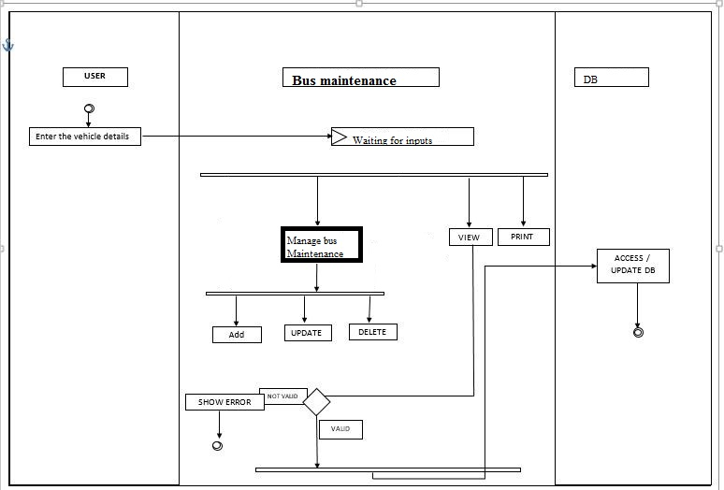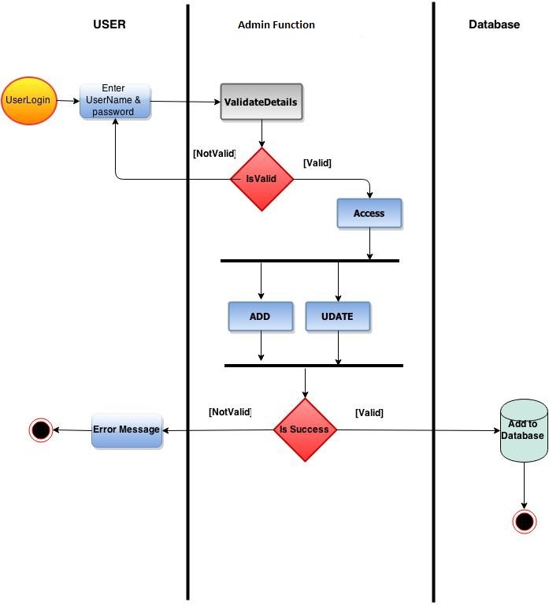

Screen Shots of project

Screen Shots of User Profile

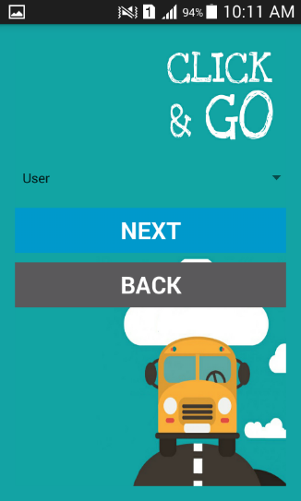 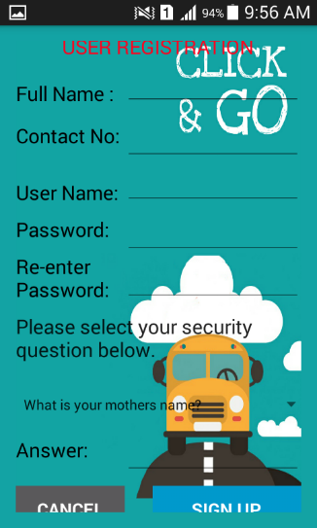 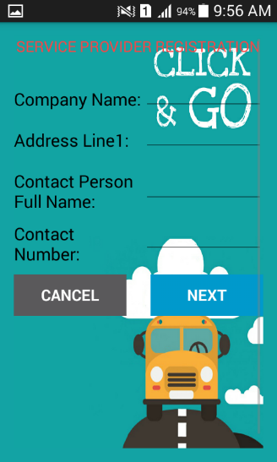

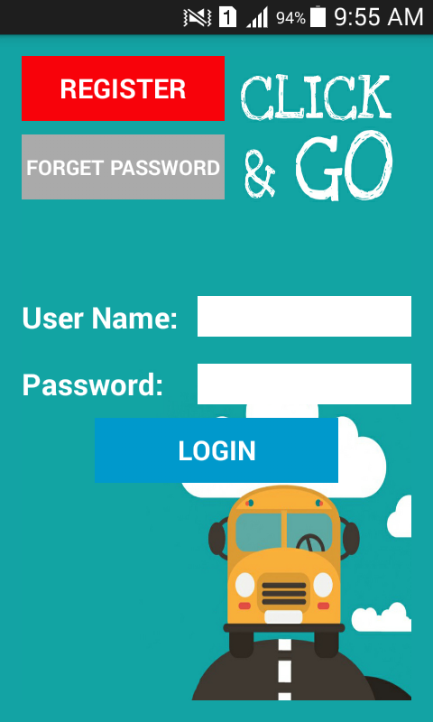

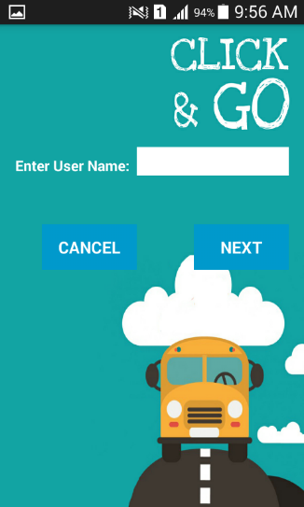 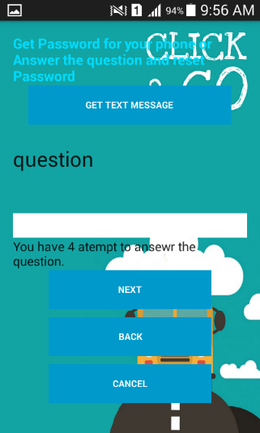

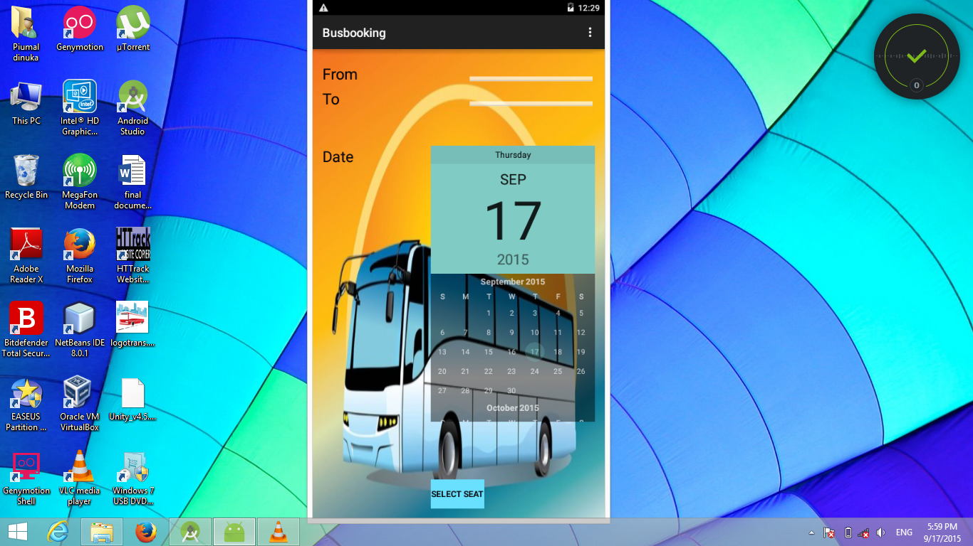Screen Shots of Booking

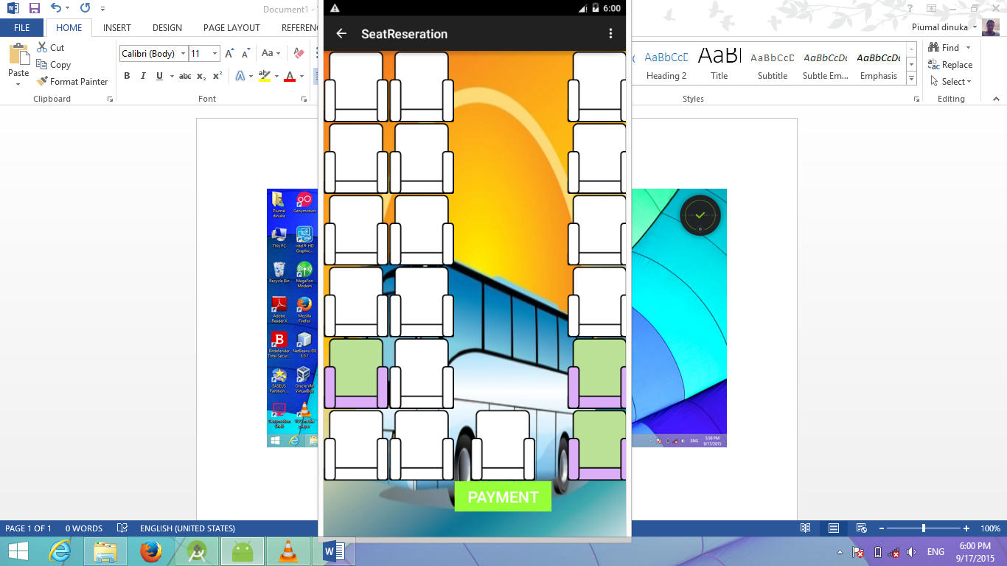

**Conclusion**

The main purpose of this system is to provide a user friendly centralized android application to the company and satisfy their loyal customers.

**Online Bus Booking app is an Android based system which will Help to the passenger .**Our target is to provide an App which provides all those facilities to people can be saved the time and energy. Easily can get this app from Android market .anyone can download it and use it easily

because it is user friendly.

**Hence the quality of service of the Travels can be improved through this Application.**

The main purpose of this system is to provide a user friendly centralized android application to the company and satisfy their loyal customers.

The project has highlighted the main drawbacks of the current log book system in RSL and designed an automated, centralized computerizes system where all the aspects related to a complete management of a company is done. Main benefit of this BMS is to centralize all the functions related to the system. Since it is an old company they used to do all their company work manually. They used papers and log books for this purpose. They have faced many problems such as inaccurate data, inefficient outputs, and unreliable information due to this.

To overcome this situation our group came up with a system where all the functions of the company day today activities done through a centralized computerized system which helps the management to do the office work methodically. From this system, time can be saved and efficiency of the company can be improved. And also Information obtained using this system can be much more reliable than earlier. Their day today activities will be more realistic, convenient and the results they will obtain using this system will be much more accurate.

And also we have implemented a web application for the company which will help them to widespread their market and globalize the business. The customers can easily view and reserve their products without coming to the company. The main purpose of this system is to provide a user friendly centralized computer system to the company and satisfy their loyal customers.

BMS will be more utilized with extra features which will enhanced the system user friendliness and easy to use the company daily activities.

**Notification Center**

Important remainders of each user will be shown in this section with user friendly and efficiently.